**MY SQL QUERIES DOCUMENT**

**BANK LOAN PROJECT**

**BANK LOAN REPORT | DATA CLEAN**

* **CREATE bank_loan_db DATABASE**

CREATE DATABASE bank_loan_db;

* **Data Types of Different Columns Before Cleaning**

DESCRIBE Bank_loan;

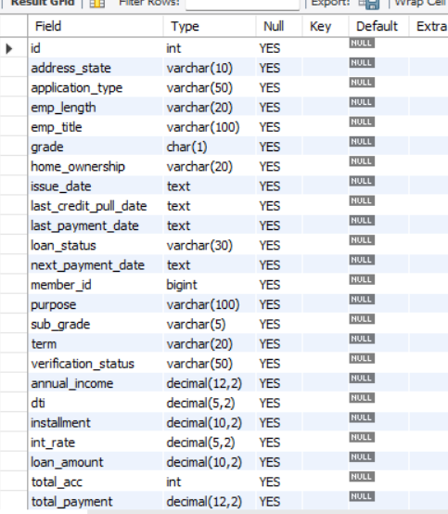

* **Convert Date (issue_date) Column To Proper Date Format**

UPDATE bank_loan

SET issue_date = STR_TO_DATE(issue_date,'%d-%m-%Y');

* **Alter Date (issue_date) Column To Date Data Type**

ALTER TABLE bank_loan MODIFY COLUMN issue_date DATE;

* **Convert Date (last_credit_pull_date) Column To Proper Date Format**

UPDATE bank_loan

SET last_credit_pull_date = STR_TO_DATE(last_credit_pull_date,'%d-%m-%Y');

* **Alter Date (last_credit_pull_date) Column To Date Data Type**

ALTER TABLE bank_loan MODIFY COLUMN last_credit_pull_date DATE;

* **Convert Date (last_payment_date) Column To Proper Date Format**

UPDATE bank_loan

SET last_payment_date = STR_TO_DATE(last_payment_date,'%d-%m-%Y');

* **Alter Date (last_payment_date) Column To Date Data Type**

ALTER TABLE bank_loan MODIFY COLUMN last_payment_date DATE;

* **Convert Date (next_payment_date) Column To Proper Date Format**

UPDATE bank_loan

SET next_payment_date = STR_TO_DATE(next_payment_date,'%d-%m-%Y');

* **Alter Date (next_payment_date) Column To Date Data Type**

ALTER TABLE bank_loan MODIFY COLUMN next_payment_date DATE;

* **Data Types of Different Columns After Cleaning**

DESCRIBE Bank_loan;

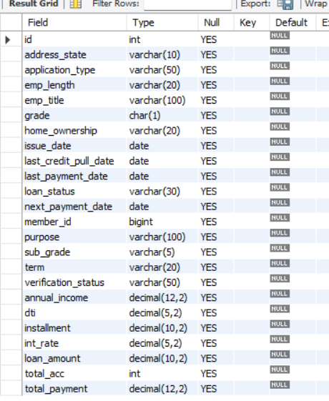

**BANK LOAN REPORT | SUMMARY**

**KPI’s REQUIREMENT**

**1. LOAN APPLICATION ANALYSIS**

1. **Total Application**

SELECT COUNT(id) AS 'Total_Loan_Applications' FROM Bank_loan;

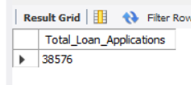

1. **Month_To_Date**

SELECT CONCAT(ROUND(COUNT(id)/1000,1),'K') AS 'CM_Total_Loan_Applications'

FROM Bank_loan

WHERE MONTH(issue_date)=12 AND YEAR(issue_date) = 2021; *-- Latest Year is 2021 And Latest Month is Dec*

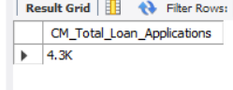

1. **Motnh_on_Month**

SELECT CONCAT(ROUND((COUNT(id)-LAG(COUNT(id)) OVER())/LAG(COUNT(id)) OVER()*100,1),'%') AS 'MoM_Increase_Percentage' FROM bank_loan

WHERE MONTH(issue_date) IN (11,12) *-- 11 is Previous Month and 12 is Current Month*

AND YEAR(issue_date) = 2021

GROUP BY MONTH(issue_date);

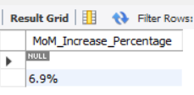

**2. FUND ANALTSIS**

1. **Total Funded Amount**

SELECT CONCAT(ROUND(SUM(loan_amount)/1000000,1),"M")

AS 'Total_Funded_Amount' FROM Bank_loan;

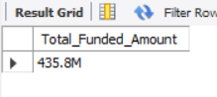

1. **Month_To_Date**

SELECT CONCAT(ROUND(SUM(loan_amount)/1000000,1),"M") AS 'CM_Total_Funded_Amount' FROM Bank_loan

WHERE MONTH(issue_date)=12 AND YEAR(issue_date) = 2021; *-- Latest Year is 2021 and Latest Month is Dec*

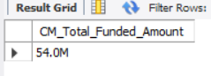

1. **Motnh_on_Month**

SELECT CONCAT(ROUND((SUM(loan_amount)-LAG(SUM(loan_amount)) OVER())/LAG(SUM(loan_amount)) OVER()*100,1),'%') AS

'MoM_Increase_Percentage' FROM bank_loan

WHERE

MONTH(issue_date) IN (11,12) *-- 11 is Previous Month and 12 is Current Month*

AND YEAR(issue_date)

GROUP BY MONTH(issue_date);

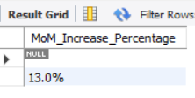

**3. AMOUNT RECEIVED ANALTSIS**

1. **Total Received Amount**

SELECT CONCAT(ROUND(SUM(total_payment)/1000000,1),"M") AS 'Total_Received_Amount' FROM Bank_loan;

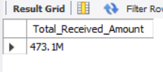

1. **Month_To_Date**

SELECT CONCAT(ROUND(SUM(total_payment)/1000000,1),"M") AS 'CM_Total_Received_Amount' FROM Bank_loan

WHERE MONTH(issue_date)=12 AND YEAR(issue_date) = 2021; *-- Latest Year is 2021 and Latest Month is Dec*

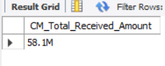

1. **Motnh_on_Month**

SELECT CONCAT(ROUND((SUM(total_payment)-LAG(SUM(total_payment)) OVER())/LAG(SUM(total_payment)) OVER()*100,1),'%')

AS 'MoM_Increase_Percentage' FROM bank_loan

WHERE MONTH(issue_date) IN (11,12) *-- 11 is Previous Month and 12 is Current Month*

AND YEAR(issue_date)

GROUP BY MONTH(issue_date);

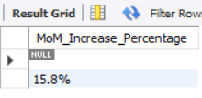

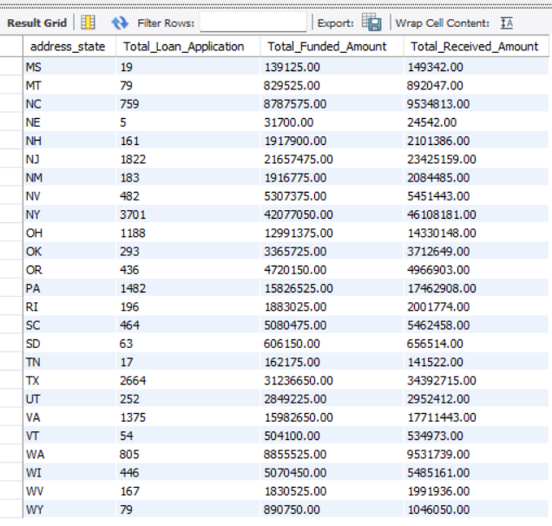

**4. INTEREST RATE ANALTSIS**

1. **Average Interest Rate**

SELECTCONCAT(ROUND(AVG(INt_rate)*100,2),'%') AS 'Average_Interest_Rate' FROM Bank_loan;

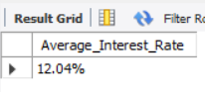

1. **Month_To_Date**

SELECT CONCAT(ROUND(AVG(int_rate)*100,1),'%') AS 'CM_Average_Interest_Rate' FROM Bank_loan

WHERE MONTH(issue_date)=12 AND YEAR(issue_date) = 2021; *-- Latest Year is 2021 and Latest Month is Dec*

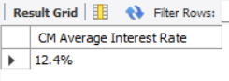

1. **Motnh_on_Month**

SELECT CONCAT(ROUND((AVG(int_rate)-LAG(AVG(int_rate)) OVER())/LAG(AVG(int_rate)) OVER()*100,1),'%') AS 'MoM_Increase_Percentage' FROM bank_loan

WHERE MONTH(issue_date) IN (11,12) *-- 11 is Previous Month and 12 is Current Month*

AND YEAR(issue_date)

GROUP BY MONTH(issue_date);

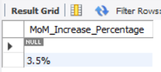

**5. DEBT-TO-INCOME RATIO (DTI) ANALYSIS**

1. **Average Debt-to-Income Ratio**

SELECT CONCAT(ROUND(AVG(dti)*100,2),'%') AS 'Average_DTI' FROM Bank_loan;

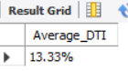

1. **Month_To_Date**

SELECT CONCAT(ROUND(AVG(dti)*100,1),'%') AS 'CM_Average_DTI' FROM Bank_loan

WHERE MONTH(issue_date)=12 AND YEAR(issue_date) = 2021; *-- Latest Year is 2021 and Latest Month is Dec*

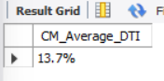

1. **Motnh_on_Month**

SELECT CONCAT(ROUND((AVG(dti)-LAG(AVG(dti)) OVER())/LAG(AVG(dti)) OVER()*100,1),'%') AS 'MoM_Increase_Percentage' FROM bank_loan

WHERE MONTH(issue_date) IN (11,12) *-- 11 is Previous Month and 12 is Current Month*

AND YEAR(issue_date)

GROUP BY MONTH(issue_date);

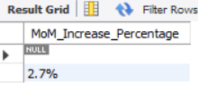

**GOOD LOAN ANALYSIS**

1. **Good Loan Percentage**

WITH Cte_Good AS

(SELECT COUNT(id) FROM bank_loan

WHERE loan_status IN ('Current','Fully Paid'))

SELECT CONCAT(ROUND((SELECT * FROM Cte_Good)/COUNT(*)*100,1),'%') AS 'Good_Loan_ Percentage' FROM bank_loan;

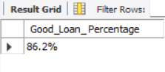

1. **Good Loan Applications**

SELECT COUNT(id) AS 'Good_Loan_Applications'

FROM Bank_loan

WHERE loan_status IN ('Current' , 'Fully Paid');

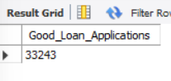

1. **Good Loan Funded Amount**

SELECT CONCAT(ROUND(SUM(loan_amount)/1000000,1),"M") AS 'Good_Loan_Funded_Amount' FROM Bank_loan

WHERE loan_status IN ('Current' , 'Fully Paid');

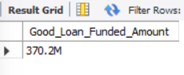

1. **Good Loan Amount Received**

SELECT CONCAT(ROUND(SUM(total_payment)/1000000,1),"M") AS 'Good_Loan_Amount_Received' FROM Bank_loan

WHERE loan_status IN ('Current' , 'Fully Paid');

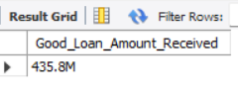

**BAD LOAN ANALYSIS**

1. **Bad Loan Percentage**

WITH Bad_loan_Calcultion AS

(SELECT COUNT(id) AS Total_Application,

SUM(CASE WHEN loan_status IN ('Charged Off') THEN 1 ELSE 0 END) AS Bad_Application FROM bank_loan)

SELECT CONCAT(ROUND(Bad_Application/Total_Application*100,1),'%') AS 'Bad_Loan_Percentage' FROM Bad_loan_Calcultion;

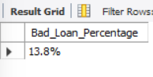

1. **Bad Loan Applications**

SELECT COUNT(id) AS 'Bad_Loan_Applications'

FROM Bank_loan

WHERE loan_status ='Charged Off';

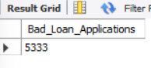

1. **Bad Loan Funded Amount**

SELECT CONCAT(ROUND(SUM(loan_amount)/1000000,1),"M") AS 'Bad_Loan_Funded_Amount' FROM Bank_loan

WHERE loan_status ='Charged Off';

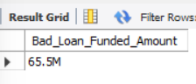

1. **Bad Loan Amount Received**

SELECT CONCAT(ROUND(SUM(total_payment)/1000000,1),"M") AS 'Bad_Loan_Amount_Received' FROM Bank_loan

WHERE loan_status ='Charged Off';

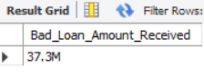

**LOAN STATUS**

SELECT loan_status AS 'Loan_Status',COUNT(id) AS 'Loan_Application',SUM(loan_amount) AS 'Total_Funded_Amount' , SUM(total_payment) AS 'Total_Received_Amount', ROUND(AVG(int_rate)*100,2) AS "Interest_Rate(%)", ROUND(AVG(dti)*100,2) AS "DTI(%)" FROM bank_loan GROUP BY loan_status ORDER BY Loan_Application desc;

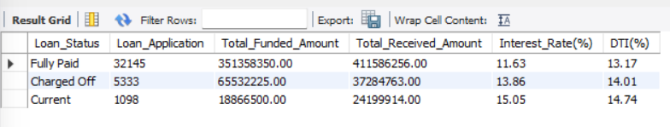

SELECT loan_status AS 'Loan_Status',SUM(loan_amount) AS 'MTD_Total_Funded_Amount' ,

SUM(total_payment) AS 'MTD_Total_Received_Amount' FROM bank_loan

WHERE MONTH(issue_date)=12 AND YEAR(issue_date) = 2021 -- Latest Year is 2021 and Latest Month is Dec

GROUP BY loan_status;

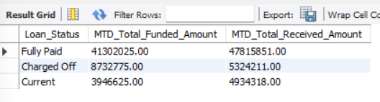

**BANK LOAN REPORT | OVERVIEW**

1. **Monthly Trends By Issued Date**

SELECT MONTH(issue_date) AS 'Row',MONTHNAME(issue_date) AS 'Month_Name',

COUNT(id) AS 'Total_Loan_Application',CONCAT(ROUND(SUM(loan_amount)/1000000),"M") AS 'Total_Funded_Amount' , CONCAT(ROUND(SUM(total_payment)/1000000),"M") AS 'Total_Received_Amount' FROM bank_loan

GROUP BY MONTH(issue_date),MONTHNAME(issue_date)

ORDER BY MONTH(issue_date) ASC;

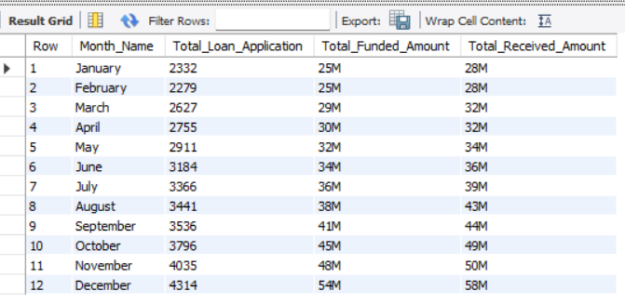

1. **Loan Term Analysis**

SELECT Term AS 'Loan_Duration',COUNT(id) AS 'Total_Loan_Application',

CONCAT(ROUND(SUM(loan_amount)/1000000),"M") AS 'Total_Funded_Amount' ,

CONCAT(ROUND(SUM(total_payment)/1000000),"M") AS 'Total_Received_Amount' FROM bank_loan

GROUP BY Term;

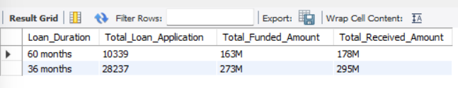

1. **Regional Analysis By State**

SELECT address_state,COUNT(id) AS 'Total_Loan_Application',SUM(loan_amount) AS 'Total_Funded_Amount' ,

SUM(total_payment) AS 'Total_Received_Amount' FROM bank_loan

GROUP BY address_state

ORDER BY address_state ASC;

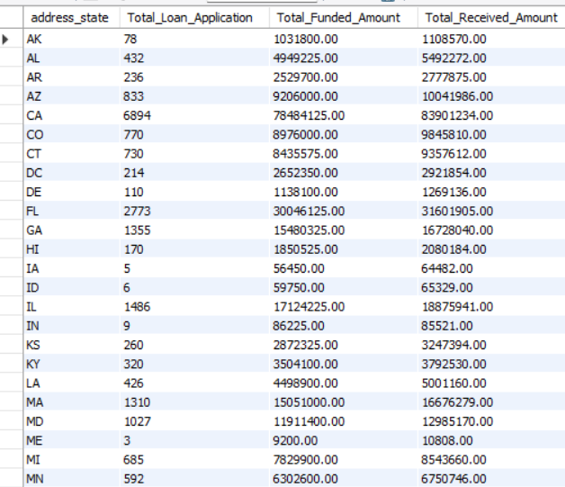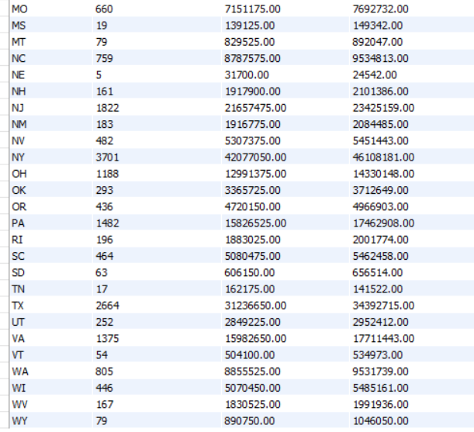

1. **Employee Length Analysis**

SELECT emp_length AS 'Emp_Length' ,COUNT(id) AS 'Total_Loan_Application',

CONCAT(ROUND(SUM(loan_amount)/1000000),"M") AS 'Total_Funded_Amount' ,

CONCAT(ROUND(SUM(total_payment)/1000000),"M") AS 'Total_Received_Amount' FROM bank_loan

GROUP BY emp_length

ORDER BY CAST(SUBSTRING(emp_length,1,2) AS UNSIGNED) ASC;

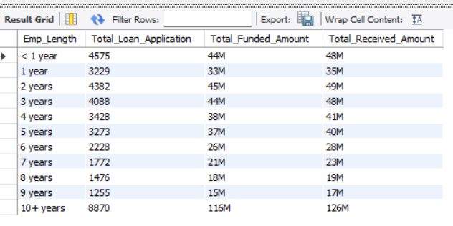

1. **Home Ownership Analysis**

SELECT home_ownership AS 'Home_Ownership',COUNT(id) AS 'Total_Loan_Application',CONCAT(ROUND(SUM(loan_amount)/1000),"K") AS 'Total_Funded_Amount' ,

CONCAT(ROUND(SUM(total_payment)/1000),"K") AS 'Total_Received_Amount' FROM bank_loan

GROUP BY home_ownership

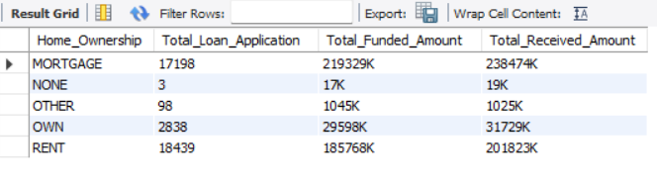ORDER BY home_ownership ASC;

1. **Loan Purpose Analysis**

SELECT purpose AS 'Loan_Purpose',COUNT(id) AS 'Total_Loan_Application',

CONCAT(ROUND(SUM(loan_amount)/1000000,1),"M") AS 'Total_Funded_Amount' ,

CONCAT(ROUND(SUM(total_payment)/1000000,1),"M") AS 'Total_Received_Amount' FROM bank_loan

GROUP BY purpose

ORDER BY purpose ASC;

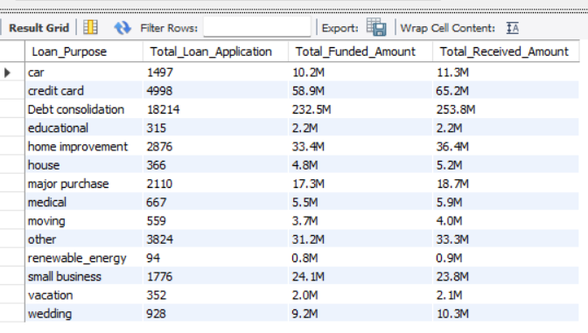

1. **Overall Detailed Analysis**

SELECT id AS 'Loan_ID', grade AS 'Grade' , sub_grade AS 'Sub_Grade', home_ownership AS 'Home_Ownership',

issue_date AS 'Loan_Issue',

purpose AS 'Loan_Purpose',

int_rate*100 AS 'Int_Rate(%)',installment AS Installment, loan_amount AS 'Funded_Amount',

total_payment AS 'Amount_Collected' FROM Bank_loan;

